Task 1: SQL-Based Traffic Analysis
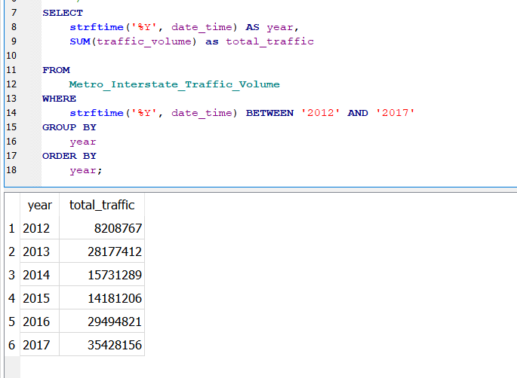
  year | total_traffic | count of date_time | change from previous year
  2012 | 8,208,767 | 2559
  2013 | 28,177,412 | 8573 | 19,968,645
  2014 | 15,731,289 | 4839 | -12,446,123
  2015 | 14,181,206 | 4373 | - 1,550,083
  2016 | 29,494,821 | 9306 | 15,313,615
  2017 | 35,428,156 | 10605 | 5,933,335
1.2 Analyse annual traffic trends
- Years 2013, 2016, and 2017 recorded increases in traffic volume (highlighted in red), while 2014 and 2015 recorded decreases (highlighted in green).
- Two key observations:
  - The continuous decline in traffic volume during 2014 and 2015 suggests a significant change in travel patterns. This could be attributed to factors such as reduced vehicle usage, changes in transportation policies, or potential gaps in data collection. My belief is the latter reason of potential gap in data, as exhibited by the steep drop in count of datapoints for 2014 and 2015 comparted to other years.
  - In 2016, traffic volume nearly doubled compared with 2015, returning to levels similar to 2013, indicating a substantial recovery in traffic activity.
1.3 Analyse temperature around holidays
- Labor Day: Total traffic peaked in 2016, coinciding with a lower average temperature compared with 2015 and 2017. This may suggest that cooler temperatures encouraged greater travel activity.
- New Year's Day: Data was only available for 2016 and 2017. The sharp decline in traffic in 2017 coincided with a rise in average temperature, further suggesting a possible inverse relationship between temperature and traffic volume, similar to the Labor Day trend.
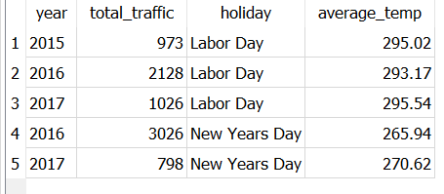
Task 2: Descriptive Statistics and Correlation
2.1 Traffic volume statistics
Interpret what these statistics tell you about traffic volume and its variability.
Statistics | Results | Interpretation
Mean | 3,260 | This tells me that the average traffic volume is 3260
Median | 3,380 | This tells me that the median is not far from the mean.
Standard deviation | 1,987 | This is quite a large standard deviation, indicating that the datapoints deviate quite a bit from the mean.
Variance | 4,191,889 | This is quite a large variance, showing greater dispersion amongst the data
Range | 0 to 7,280 | This is a large spread of values

2.2 Correlation analysis
The correlation coefficient calculated using the excel formula is 0.130. This is a positive relationship where both variables move in the same direction. As temperature increases, traffic volume will increase too. However, as the coefficient is closer to 0 than 1, it suggests a weak relationship.
Correlation does not imply causation as correlation is just a statistical measure shows that two things change together.
For example, all people who consume water will experience death at some point. However, this does not mean that drinking water causes death. Just because two things happen, does not mean they are related or caused by the other.

Task 3: Probability and Congestion Analysis
3.1 Basic probability
Basic probability | Value
P(Congestion) | 14.73%
P(Clear Weather) | 27.78%
P(Congestion AND Clear Weather) | 4.09%

3.2 Conditional probabilituy
Conditional probability | Value
P(Clear Weather | Congestion) | 24.83%
P(High Temperature | Congestion), where high temperature > 292K | 26.30%
Weather conditions and congestion cannot be considered independent events as P(A ∩ B) which is 3.66% is not equal to P(A) × P(B) which is 4.09%. This suggests that there is a negative association between weather and congestion as P(A ∩ B) is less than P(A) × P(B).
 | Congestion | No congestion
Clear weather | 1,763 | 11,628
Cloudy weather (assuming all other weather that is NOT clear) | 5,337 | 29,476
Odds ratio: 0.84
As it is <1, the odds of congestion in clear weather are about 0.84 times the odds in cloudy weather. Hence, compared with cloudy weather, clear weather is associated with lower odds of congestion.

Overall, the probability analysis suggests that weather conditions have an association with congestion. The P(A ∩ B) 3.66% is lower than P(A) × P(B) 4.09% under independence, indicating a negative association between clear weather and congestion. This is also supported by the odds ratio of 0.84, which shows that the odds of congestion in clear weather are approximately 16% lower than in cloudy weather. Therefore, clear weather is associated with a lower likelihood of congestion compared with cloudy weather, although weather alone may not fully explain congestion levels as there may be other variables to consider too such as temperature.

Task 4: Power BI Traffic Intelligence Dashboard
4.2 C. Weather impact
Analyse average traffic by weather condition and answer:
- Which weather condition has the highest average traffic? Clouds
- Which has the lowest? Squall
- What is the difference between the highest and lowest average traffic? 1,556.71
D. Temperature and traffic
Discuss:
- Whether a visible relationship exists. There is a positive relationship between the two where traffic volume and temperature increase together. This can be seen from the trendline, although the locations of the datapoints suggests it is not a strong relationship.
- The temperature range associated with higher traffic. The full temperature range of 0 to 35 celsius is observed for the high traffic category
- Any notable outliers. There are two datapoints with negative 200+ temperature Celsius, suggesting that they are erroneous datapoints as it is not within the range of regular weather.
Most important findings and implications for smart city mobility team
The preliminary findings suggest that there is a relationship between temperature, weather conditions and traffic congestion, which warrants further investigation and more detailed analysis.
SQL analysis indicates that information is missing for certain years within the dataset. Further work is therefore required to assess the cleanliness, consistency, and completeness of the data. The analysis also suggests a potential relationship between temperature and traffic volume, which should be explored further.
Descriptive statistics highlight potential data quality issues, particularly the large range and high variability observed in traffic volume, supporting the data completeness concerns of the SQL analysis. These findings warrant further investigation to determine whether the variation reflects genuine traffic patterns or possible anomalies within the dataset.
The probability analysis suggests an association between weather conditions and congestion. However, the results also indicate that additional variables may need to be considered to better explain the factors contributing to congestion.
The Power BI analysis has enabled preliminary exploration of the dataset, including the ranking of different weather conditions and the identification of hourly traffic patterns. The findings indicate that traffic volume is generally higher between 0600 and 2200 hours. This provides a useful basis for narrowing the scope of further analysis, particularly by focusing on this period when investigating the relationship between weather conditions and traffic congestion.
For a smart city mobility team, these preliminary findings highlight the potential for weather and traffic data to improvement of traffic management and commuter mobility. However, the identified data-quality issues should be addressed before the dataset is used for operational decision-making.

